How to View Released Erection Drawing List & Complete Released Drawing List
- When you are at site and connected to internet. Use following URL
http://cloud.isgec.co.in/WebERP1/Default.aspx
- When you are in office and connected to LAN, go to the Joomla and click on link as shown below.
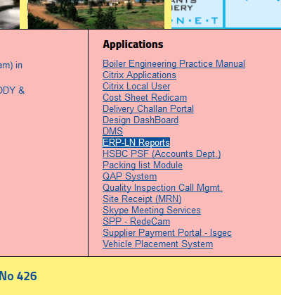
- When link is opened in browser, following screen will appear.
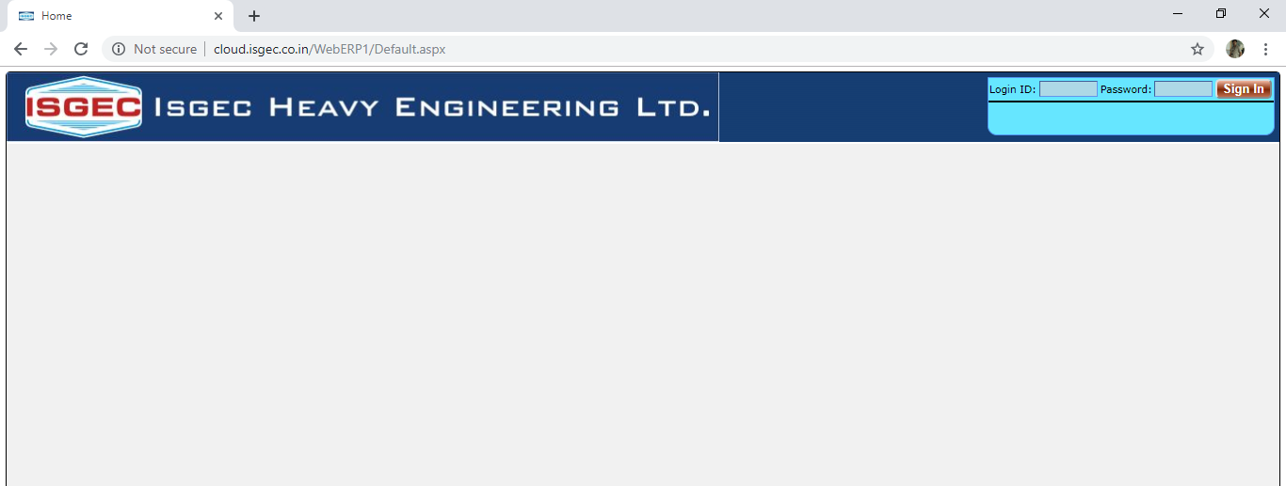

- Use the User ID & Password, which is used in Leave Management System, to login in the system.
- A menu will appear, if menu does not appear, pl. send an e-mail to joomlasupport@isgec.co.in. Mention your employee code and ask for Erection Document List authorization.
- Click on the Erection Drawing List menu option.
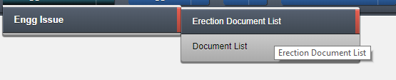
- Following screen will appear.
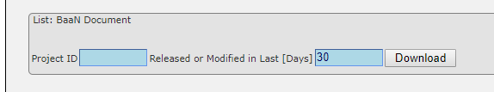
- Enter the Project ID, enter the No. of Days and click on Download button.
- An Excel file will be downloaded, save the file on your system.
- There will be two sheets in Excel File, one in which you would see the drawings released or modified in Last 30 Days (or days entered by you).
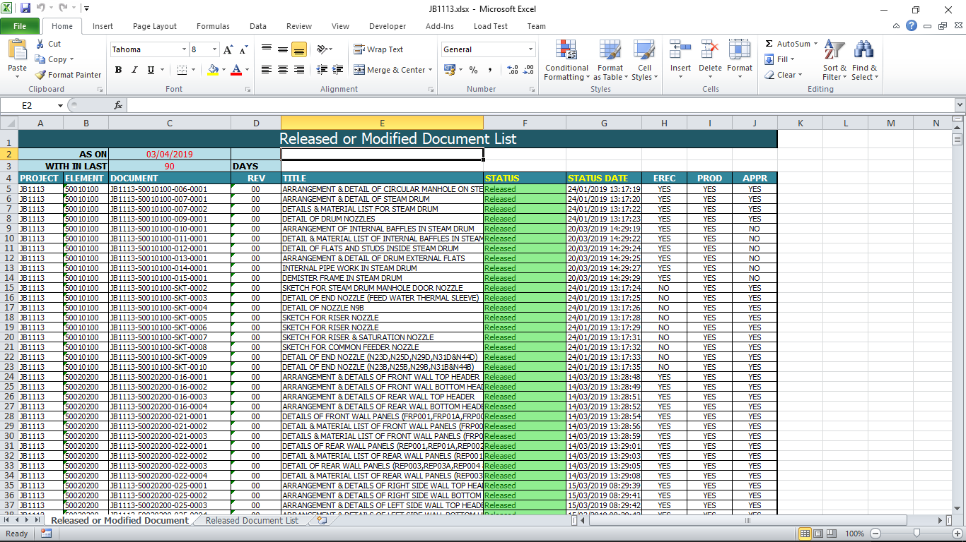
- On other sheet complete released drawing list of the Project is listed.
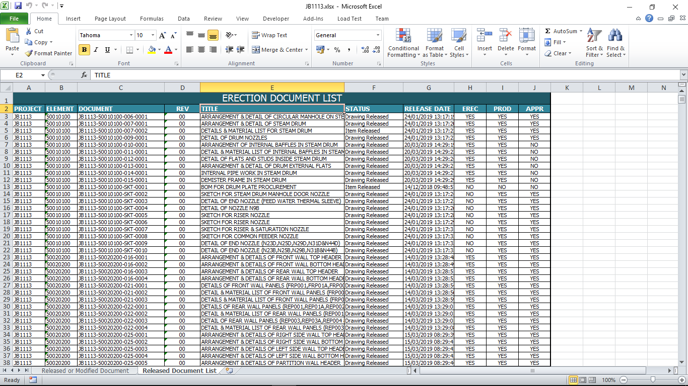

***** END ****

